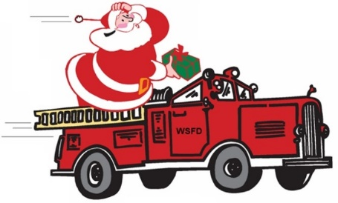**Blooming Grove’s 10th Annual Christmas Parade 2021**

**ENTRY FORM and WAIVER & HOLD HARMLESS AGREEMENT**

|  |  |
| --- | --- |
| **Group / Organization / Business Name** |  |
| **Contact Person** |  |
| **Contact Phone Number** |  |
| **Contact E-Mail** |  |
| **Parade entry vehicle (check appropriate category)** | ( ) Fire truck ( ) Ambulance  ( ) Police vehicle ( ) Tow truck  ( ) Farm vehicle ( ) Antique vehicle  ( ) Private vehicle ( ) Float  ( ) Other (explain) ___________________________ |
| **Please provide a brief description of your entry** |  |
| **Will your entry have music?** | ( ) Yes ( ) No |

In consideration of the acceptance by the Blooming Grove Chamber of Commerce of the entry of the undersigned in the Washingtonville Christmas Parade to be held in the Village of Washingtonville, NY on Saturday, December 4th, 2021, the undersigned does hereby remise, release, and forever discharge the Blooming Grove/Washingtonville Chamber of Commerce, and the Village of Washingtonville, and their officers, members, representatives, successors or assigns of and from all and any manner of actions, cause of actions, suits, debts, trespasses, damage and injuries, which may be sustained to equipment or personnel as a result of its participation in activities in conjunction with the Washingtonville Christmas Parade in the Village of Washingtonville on Saturday, December 4th, 2021 and does hereby further covenant and agree to hold harmless and defend and to indemnify and keep indemnified the Blooming Grove/Washingtonville Chamber of Commerce, and the Village of Washingtonville and Their officers, members, representatives, successors or assigns and to hold and save them harmless from and against all claims and damages whatsoever as a result of said participation.

Representative’s Signature________________________________________________

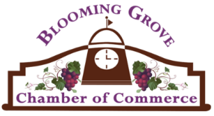Print Representative’s Name______________________________________________Date______________________________**Completed ENTRY FORM/WAIVER can be faxed to 845-496-3058, e-mailed to** [**fdniemann@gmail.com**](mailto:fdniemann@gmail.com) **or mailed to BGW Chamber c/o Walden Savings Bank 127 East Main St. Washingtonville NY 10992 by 11/30/2021. Questions? Call us at 845-500-1269.**