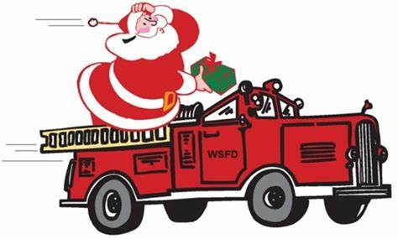

**Blooming Grove’s 10th Annual Christmas Parade Rules and Information**

The Blooming Grove Chamber of Commerce welcomes you to town for the

**10th** Annual Blooming Grove Christmas Parade!

This is a family oriented and fun parade. Our goal is for our spectators and participants to have an amazing time. Please help us reach that goal!

* This is a vehicle only parade. All participants must be in or on a vehicle or float.
* Walking the parade route is not allowed.
* Please do not block any driveways in the line-up area.
* Bathrooms WILL NOT be available in the line-up area. Please plan ahead!
* Please keep the use of sirens and air horns to a minimum. Several of our entries have music and we want the music to be heard by the spectators.
* All entries should be at the line up area by 5pm to allow time to complete your decorating in time for a 6pm start.
* NO LIVE SANTA’S ARE TO BE ON ANY ENTRY! There will be only one Santa on the last vehicle.
* Line-up will be on Decker Drive off Ahern Blvd in the Stone Ridge development
* Please do not throw any items (including candy) from the moving vehicles. This is a night time parade and visibility is limited along the parade route.

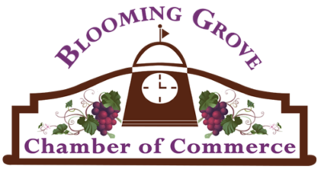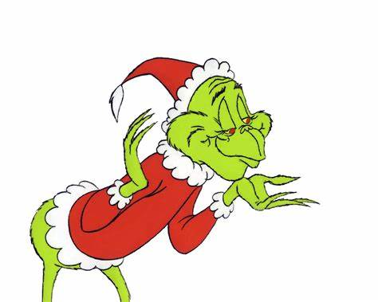

In support of our local merchants, we ask all participants to patronize our food establishments in the village. Parade specials will be available!

Any questions contact Martha B. at 845-500-1269 or Paulie N. at [fdniemann@gmail.com](mailto:fdniemann@gmail.com)

**Blooming Grove’s 10th Annual Christmas Parade Rules & Information**



**Parade Date:** Saturday, December 4th, 2021

**Time:** Assemble at 5pm. Parade begins at 6pm

**Location:** Decker Drive off Ahern Blvd in the Stone Ridge development

Follow signs off Rt. 94

**Entry Regulations:**

* Vehicles only allowed, no walkers
* All participants must be in a vehicle or on a parade float
* No Santa’s are to be on any entry.
* There will be only one Santa, on the last Fire Department vehicle in the parade provided by the Monell Engine Company.
* Vehicles/floats should be illuminated as this will be a nighttime parade
* Identify your entry. Your name/company name/organization name should be visible on your entry.

**Parade Assembly Point:**

* Decker Drive off Ahearn Blvd in the Stone Ridge development.
* All entries should be at line up at 5pm for a start time of 6pm
* Preparations to your entry can be made at Vern Allen Park earlier than 5pm if more time is needed.

**Parade Route:**

Parade will leave Vern Allen Park at 6pm sharp and will proceed down East Main

Street in to the Village. The parade will proceed through the Village on

Main Street and will disband at the Washingtonville High School on West Main Street.

**General Information:**

Music adds greatly to the parade atmosphere. Please make every effort to use

music on your entry. CD’s or IPods work well over a PA system or external

speakers.

Our goal is to minimally affect normal traffic through the village. Traffic will

be stopped at applicable intersections along the parade route as the parade

makes its way through the village so we can keep the parade intact in to the school parking lot.

**Blooming Grove’s 10th Annual Christmas Parade Rules and Information**



The last vehicle in the parade (Washingtonville FD fire truck) will carry Santa and will stop at the Village Square to drop Santa off for the tree lighting ceremony.

All vehicles are asked to continue on to the Washingtonville High School

parking lot to disband and remove any decorations or lights.

For the safety of our spectators, please do not throw any items (including

candy) from the moving vehicles. This is a night time parade and visibility along

the parade route is limited.

After the parade, ALL Eastbound traffic in to the village on Rt.94 will be prohibited to help ease congestion at and near the Tree Lighting Ceremony in the center of the village. When leaving the high school parking lot, make a right turn only on to Rt. 94 West.

Any questions contact Martha B. at 845-500-1269 or Paulie N. at [fdniemann@gmail.com](mailto:fdniemann@gmail.com)

Special thanks to Paulie and the Hudson Valley Hot Rods for assisting the Chamber with this year’s parade!

